Game Development in C++ with SFML
Install Visual Studio 2022 community edition -> install Game development with C++
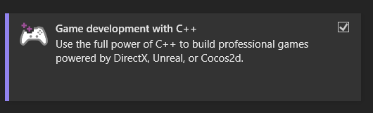
Create a new project -> Language C++ , For Windows Build -> create empty project


